

**Phone: 509-369-4145**

**98 School Drive Klickitat, WA 98628 98620**

**Klickitat School District**

***“Achieving Excellence”***

March 24, 2023

To: Klickitat Students, Parents, and Community Members

Re: Change in School Administration

Dear Families,

Many community members feel, as I do, that Klickitat School District is the heart of our community. With that in mind, I want to share with you an announcement about changes to our school leadership team and our plans to be sure school operations continue to run smoothly.

Our principal, Principal Draper, notified the district in December of their intent to resign from the principal position at the end of the school year. Since then, an earlier leave of absence was requested by Principal Draper, considered by the Board, and granted, starting after spring break – when students return on April 3rd.

A mid-school-year leadership change can be difficult, but we have worked out a plan to continue to move our school forward in a positive direction through the end of this school year.

I (Superintendent Lester) will assume principal responsibilities for the remainder of the school year, including full supervision of district staff. Of course, we will need everyone’s patience and flexibility as we strive to complete the same amount of work with fewer people.

Klickitat School District wishes Principal Draper well in future endeavors. The School Board and I will keep our community informed about the future of the principal position, including potential adjustments to that role and the hire of new staff to the administrative team.

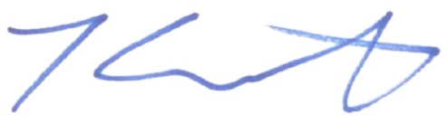Please reach out if you have questions.

Kendrick Lester

Superintendent